## Computer Networks

## Traffic shaper using Token bucket

## Assignment Report

### Under the guidance of:

### Prof.Yousaf Zarrar

Presented by:

Rudradeep Palit

11038108

**FLOWDIAGRAM:**

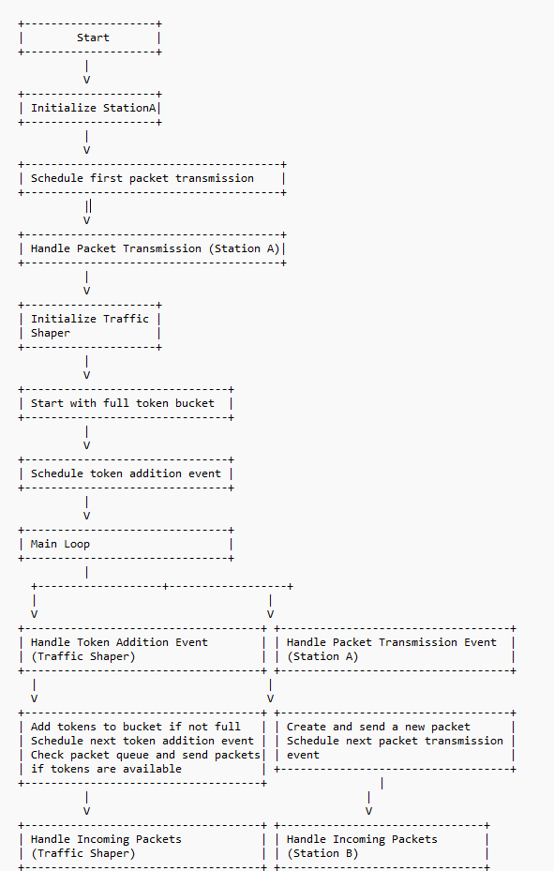

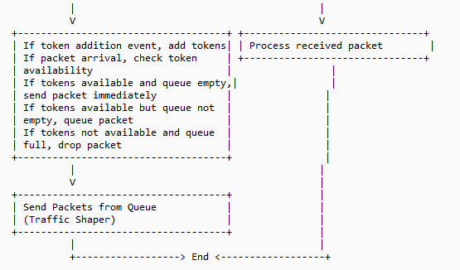

**Code Components:**

In this code, several functions are used:

* initialize(): This function is called when an instance of the module is created during simulation initialization. It's used to initialize module parameters and state variables.
* handleMessage(cMessage *msg): This function is called whenever a message is received by the module. It handles incoming messages and performs necessary actions based on the message type or content.
* finish(): This function is called when the simulation finishes. It's used for cleaning up resources and performing any necessary finalization tasks.
* sendPacketFromQueue(): This is a helper function defined in the TrafficShaper class. It sends packets from the queue when tokens are available in the token bucket.

**Simulation:**

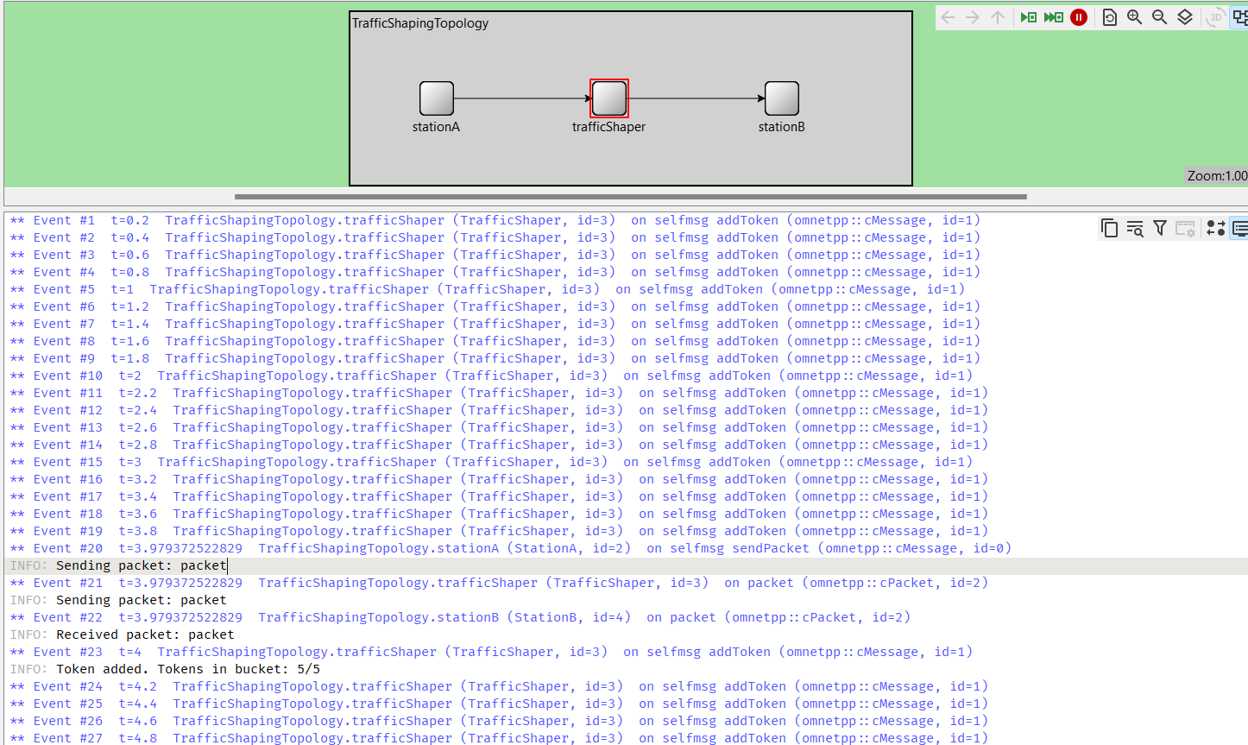

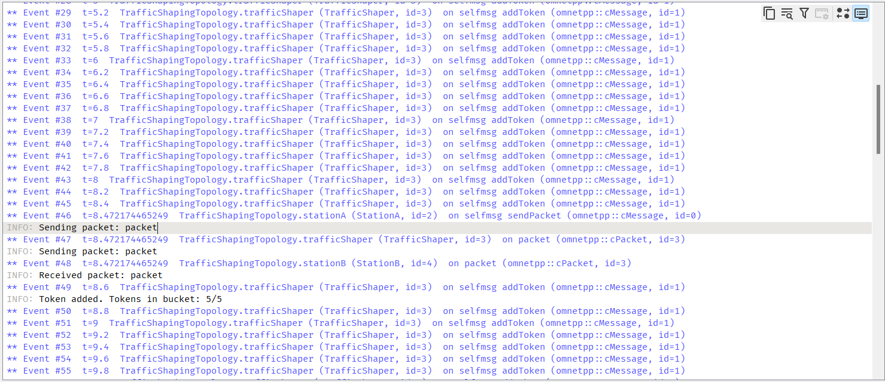

**Test Parameters:**

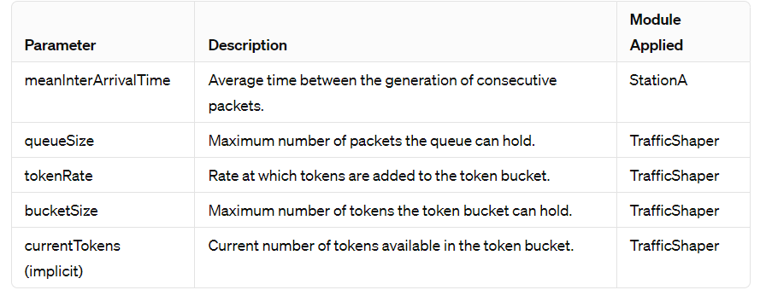

**GRAPH:**

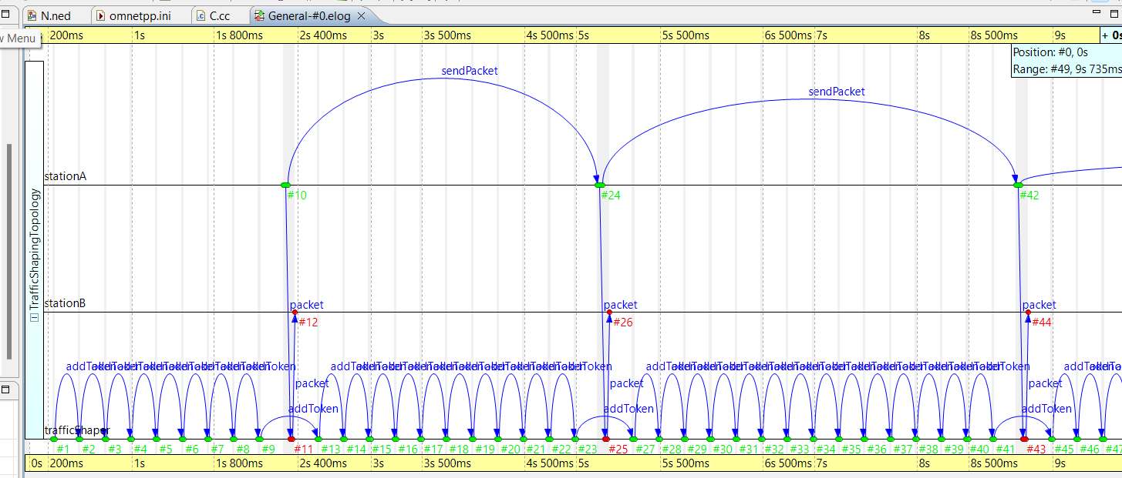

Implementation of traffic controller